CISC7204-001-M Data Science and Data Visualization · Assignment 02 (Pair Work)
Macau Tourism: Seasonality and Post-Pandemic Recovery of Visitor Arrivals and Hotel Occupancy
Project Proposal & Ideation
Group: [Group 06]
Members: WANG MENGCHEN (MC641561); YUAN DING (MC642163)

1. Ideation: Region, Domain and Research Question

1.1 Region and Domain
- Region: Macao Special Administrative Region (SAR), China.
- Domain: Tourism & hospitality (demand-side: visitor arrivals; supply-side performance: hotel occupancy).

1.2 Research Question
Main research question: How do Macau’s monthly visitor arrivals and hotel occupancy rates move together over time, and has the COVID-19 pandemic changed the seasonal pattern of Macau’s tourism?
The question is decomposed into three statistically answerable sub-questions:
- SQ1 (Seasonality): Is there a stable within-year seasonal pattern in monthly visitor arrivals, and does the post-pandemic profile (2023–2026) match the 2019 baseline?
- SQ2 (Recovery): How far has visitor demand recovered relative to the pre-pandemic baseline (2025 vs. 2019, and the 2020–2022 pandemic years)?
- SQ3 (Co-movement): How strong is the linear association between monthly visitor arrivals and the hotel occupancy rate (Pearson correlation and linear regression)?

2. Datasets and Data Sources
Both key series are official monthly statistics published by the Statistics and Census Service (DSEC) of the Macao SAR. Table 1 lists the three accessible dataset links (two official statistic tables plus the time-series database used for programmatic access).
# | Dataset | Frequency | Coverage | Access (official link)
1 | Visitor arrivals — total (人次) | Monthly | Jan 2008 – Aug 2026 | dsec.gov.mo/zh-CN/Statistic?id=402
2 | Hotel occupancy rate — hotel establishments (%) | Monthly | Jan 1997 – Aug 2026 | dsec.gov.mo/zh-CN/Statistic?id=403
3 | DSEC Time Series Database (programmatic access) | Monthly / quarterly | — | dsec.gov.mo/ts/
Table 1.
Valid Dataset Links：https://www.dsec.gov.mo/zh-CN/Statistic?id=402 ; https://www.dsec.gov.mo/zh-CN/Statistic?id=403 ; https://www.dsec.gov.mo/ts/
All figures in this proposal were retrieved on 21 October 2026 directly from the DSEC Time Series API (Key Indicators 27 and 9) and cross-validated against the official tables: for example, the sum of monthly visitor arrivals for 2025 equals 40,069,360, matching the DSEC published annual total digit-for-digit.

3. Purpose: Outcomes, Skills and Knowledge

3.1 Expected Outcomes
- A quantitative, reproducible answer to the research question (seasonality, recovery, co-movement), with all numbers traceable to official sources.
- A three-panel data visualisation that answers the question in one figure (Section 6).
- A self-contained Jupyter Notebook (.ipynb) that reproduces the whole pipeline — live API acquisition with CSV fallback, cleaning, validation, statistics and figures.
- This proposal document (DOCX/PDF), ready to submit on Moodle by the deadline.

3.2 Skills
Data acquisition from official government APIs; data cleaning and validation against published totals; time-series and correlation analysis; data visualisation with matplotlib/seaborn; reproducible documentation (Jupyter); collaborative project management.

3.3 Knowledge
Seasonality of tourism demand; post-pandemic recovery benchmarking; co-movement of demand (arrivals) and hotel performance (occupancy); and the implications of these patterns for tourism marketing analytics (pricing and promotion timing, capacity management).

4. Tasks and Deliverables
Task | Description | Deliverable
T1 | Acquire monthly DSEC series via API; merge into one tidy table; cross-check annual totals with official figures | data/*.csv (tidy monthly dataset)
T2 | Compute key statistics: annual totals, YoY drops, trough, peak month, Pearson r | analysis_stats.json
T3 | Design the three-panel visualisation answering the RQ | figures/macau_tourism_analysis.png
T4 | Write the reproducible analysis notebook (API + CSV fallback) | CISC7204_Assignment02_Analysis.ipynb
T5 | Draft and integrate this proposal (all guideline elements) | Proposal (DOCX + PDF)
Table 2. Tasks and corresponding deliverables, all included in the Moodle submission (id=1240028).

5. Success Criteria
The project is considered successful when every checklist item below is verifiable in the submitted package:
# | Criterion | Where verified
1 | Region and domain clearly stated | Section 1.1
2 | At least two accessible dataset links (three provided) | Section 2, Table 1
3 | Research question statistically answerable with monthly data | Section 1.2
4 | Visualisation directly addresses the RQ with a written justification (1–2 paragraphs) | Section 6, Figure 1
5 | Purpose covers outcomes, skills and knowledge | Section 3
6 | Tasks and deliverables fully specified | Section 4
7 | Every number traceable to DSEC official data and validated | Section 2, Appendix A
8 | Notebook reproduces the analysis end-to-end (API + CSV fallback) | Deliverable T4
9 | Collaboration plan with roles, division and ground rules | Section 7
10 | Submitted before the deadline (25 Oct 2026, 23:00) | Moodle receipt
Table 3. Success-criteria checklist (rubric).

6. Visualisation and Written Justification
Figure 1 summarises the complete analysis in three panels and is the central visual answer to the research question.
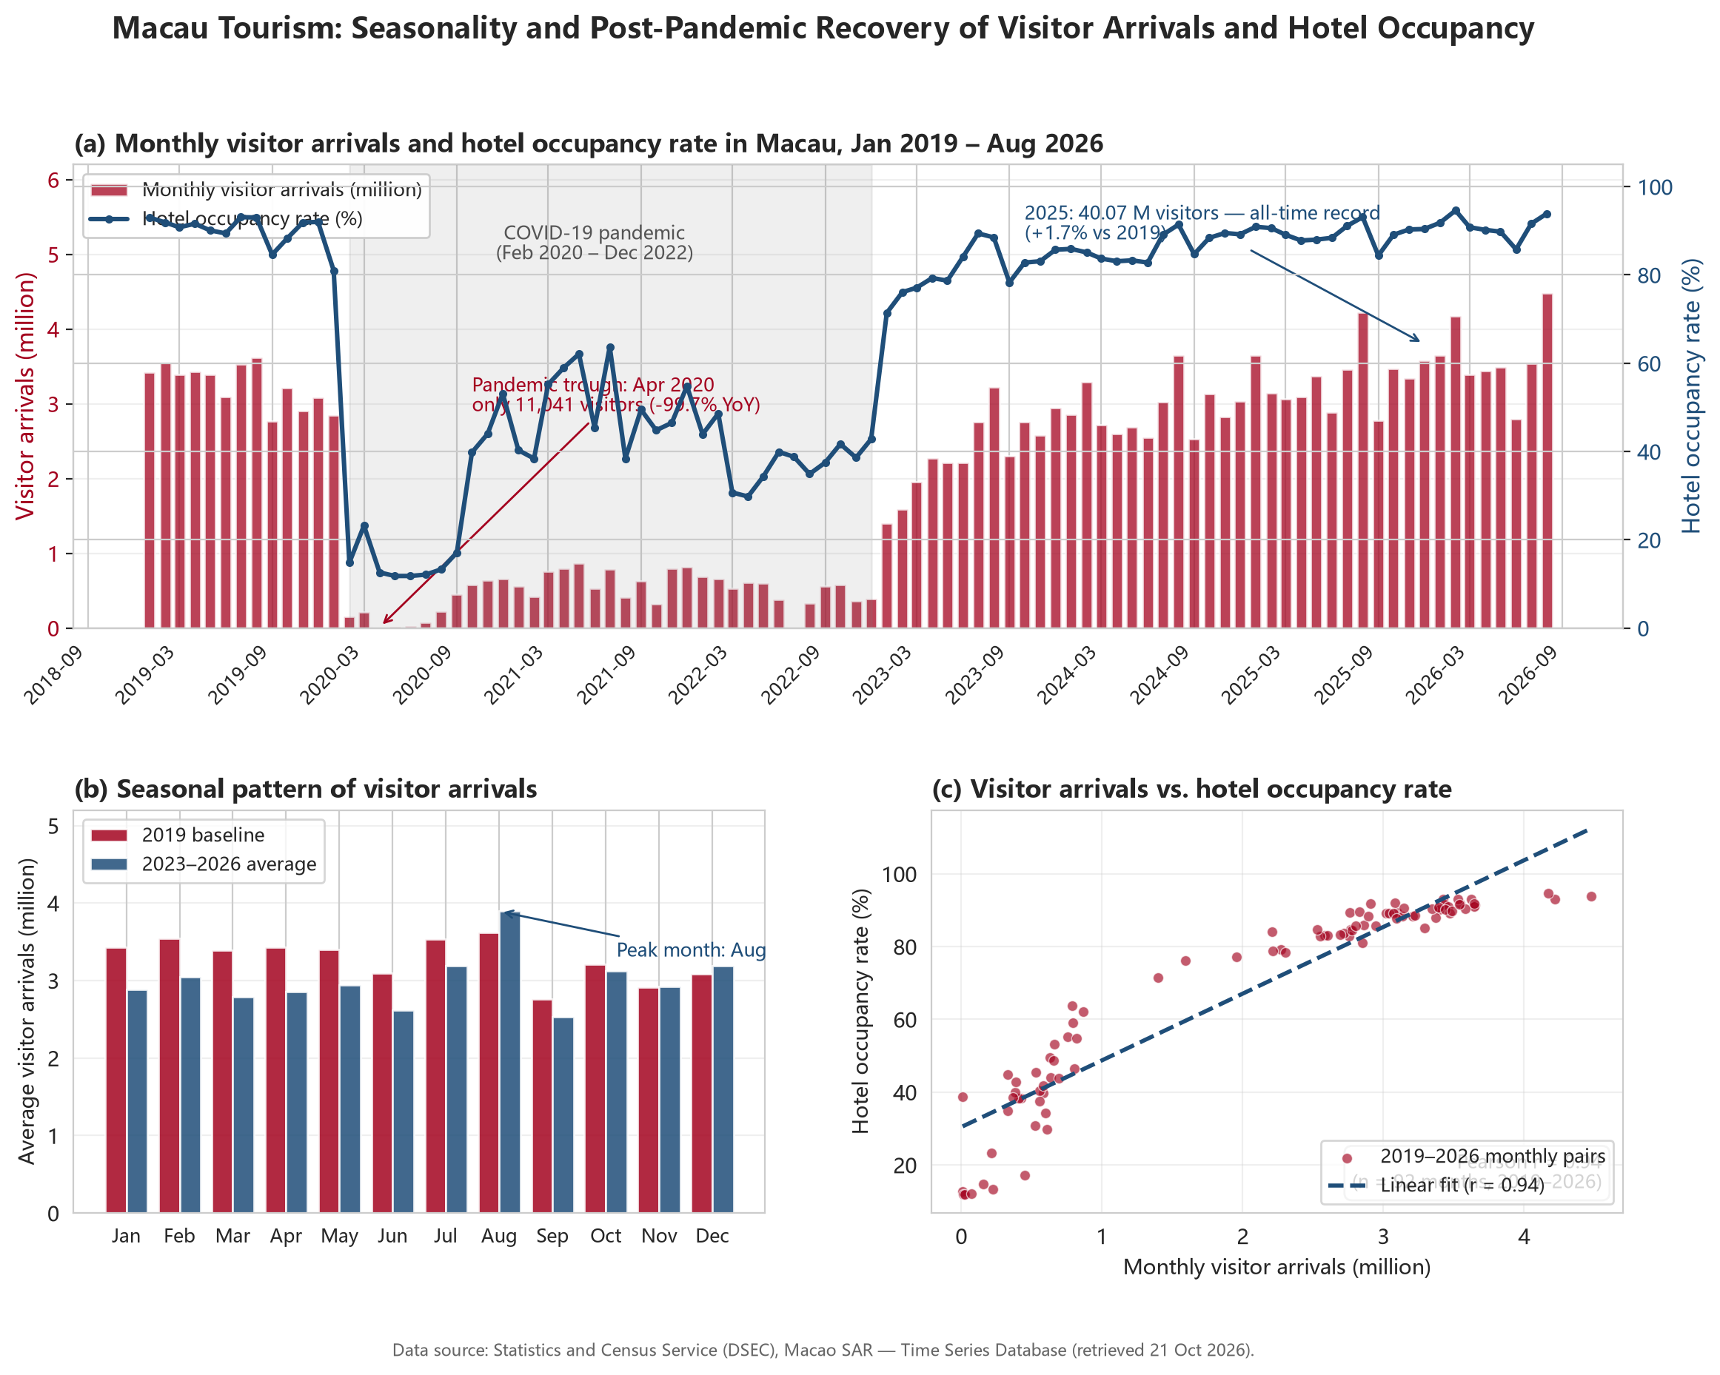
Figure 1. Macau tourism analysis, Jan 2019 – Aug 2026: (a) monthly visitor arrivals (bars, left axis) and hotel occupancy rate (line, right axis); (b) seasonal profile — 2019 baseline vs. 2023–2026 monthly average; (c) visitor arrivals vs. hotel occupancy with linear fit. Data: DSEC Time Series Database (retrieved 21 Oct 2026).
The figure answers the research question in three complementary layers. Panel (a) shows the pandemic shock and the temporal co-movement of demand and hotel performance: annual arrivals fell 85.0% in 2020, bottomed out at just 11,041 visitors in April 2020 (−99.7% year-on-year), and then recovered in a V-shape to an all-time record of 40.07 million in 2025 (+1.7% vs. 2019), while hotel occupancy followed the same trajectory (93.9% in August 2026). Panel (b) isolates the seasonal component by comparing the 2019 baseline with the 2023–2026 monthly average: the within-year pattern is stable and structural, with a strong August peak (summer holiday / Golden Week demand) and a secondary February peak around the Chinese New Year. Panel (c) quantifies the co-movement: the scatter of monthly arrivals against occupancy with a linear fit gives Pearson r = 0.943 (n = 92 months, 2019–2026), confirming that the two series move tightly together.
These findings directly support the conclusion that COVID-19, despite its short-run severity, did not permanently alter Macau’s seasonal structure, and that visitor arrivals act as a strong leading indicator for hotel occupancy. For marketing analytics this is actionable: the seasonal profile identifies the August peak and the June trough as the natural windows for demand-driven versus value-based campaigns, and monthly arrival forecasts can feed occupancy-based pricing decisions. The visualisation therefore does not merely illustrate the data — it answers each sub-question (seasonality, recovery, co-movement) with evidence.

7. Collaboration: Roles, Task Division and Ground Rules

7.1 Roles
Role | Owner | Responsibilities
Project coordinator | WANG MENGCHEN | Sets agenda, owns milestone deadlines, integrates final proposal
Scribe | YUAN DING | Records meeting minutes and key decisions
Progress tracker | WANG MENGCHEN | Tracks tasks against timeline, flags risks early
Liaison | YUAN DING | Handles instructor clarifications and submission logistics
Table 4. Team roles (2 members, shared responsibilities).

7.2 Task Division
- WANG MENGCHEN — data acquisition & cleaning, statistical analysis, success-criteria verification.
- YUAN DING — visualisation, notebook implementation, proposal drafting and final proofreading.

7.3 Ground Rules
- One weekly 30-minute synchronous check-in plus an always-on chat thread for asynchronous updates.
- Shared folder (UM/cloud drive) with versioned files; one canonical copy is the submission source of truth.
- Any decision that changes scope, data or conclusions requires both members’ consent; disagreements are settled with evidence (data/code), not opinion.
- Final integration and the submission checklist are reviewed by both members at least 24 hours before the deadline.

